Assignment – 8.5
Name: T.Harshitha
HT No: 2303A51953
Batch: 22

Task Description #1 (Username Validator – Apply AI in
Authentication Context)
• Task: Use AI to generate at least 3 assert test cases for a
function is_valid_username(username) and then implement
the function using Test-Driven Development principles.
• Requirements:
o Username length must be between 5 and 15 characters.
o Must contain only alphabets and digits.
o Must not start with a digit.
o No spaces allowed.
Example Assert Test Cases:
assert is_valid_username("User123") == True
assert is_valid_username("12User") == False
assert is_valid_username("Us er") == False
Expected Output #1:
• Username validation logic successfully passing all AI-
generated test cases.

Prompt:
‘’’generate a python code to validate the username and then implement the function using test-driven development (TDD) approach.
The username must meet the following criteria:
It must be between 5 and 15 characters long.
It can only contain alphanumeric characters (letters and numbers).
It must start with a letter.
It must not contain any spaces’’’
Code:
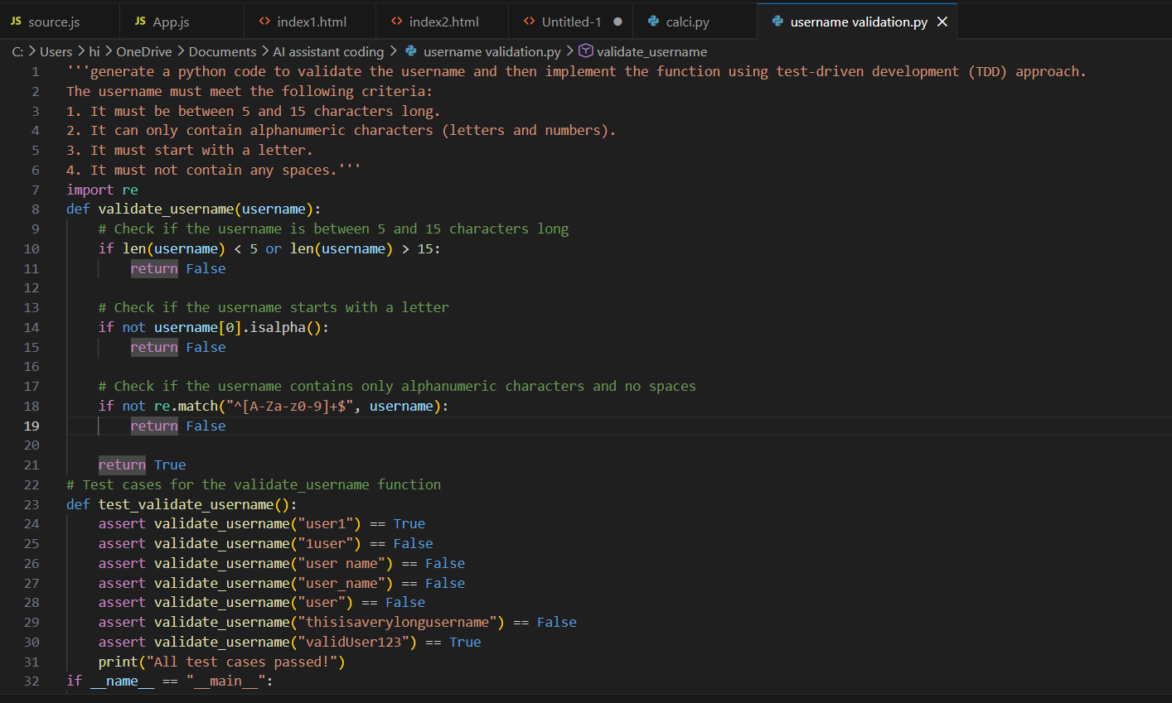
Output:

Explanation:
The validate_username function checks if the username meets all the specified criteria. It first checks the length of the username. Then it checks if the username starts with a letter. Finally, it uses a regular expression to ensure the username contains only alphanumeric characters and no spaces. The test cases cover various scenarios, including valid usernames and invalid ones. If any assertion fails, an error message will indicate which test case failed.

Task Description #2 (Even–Odd & Type Classification – Apply
AI for Robust Input Handling)
• Task: Use AI to generate at least 3 assert test cases for a
function classify_value(x) and implement it using conditional
logic and loops.
• Requirements:
o If input is an integer, classify as "Even" or "Odd".
o If input is 0, return "Zero".
o If input is non-numeric, return "Invalid Input".
Example Assert Test Cases:
assert classify_value(8) == "Even"
assert classify_value(7) == "Odd"
assert classify_value("abc") == "Invalid Input"
Expected Output #2:
• Function correctly classifying values and passing all test
cases.

Prompt:
'''generate a python code for even odd number checke , implement using conditional logic and loops by rebust input handling and error handling. the input number must be an integer.
If input is 0, return "Zero".
If input is non-numeric, return "Invalid Input"
generate atleat 3 assert test cases for the even_odd_checker function '''

Code:
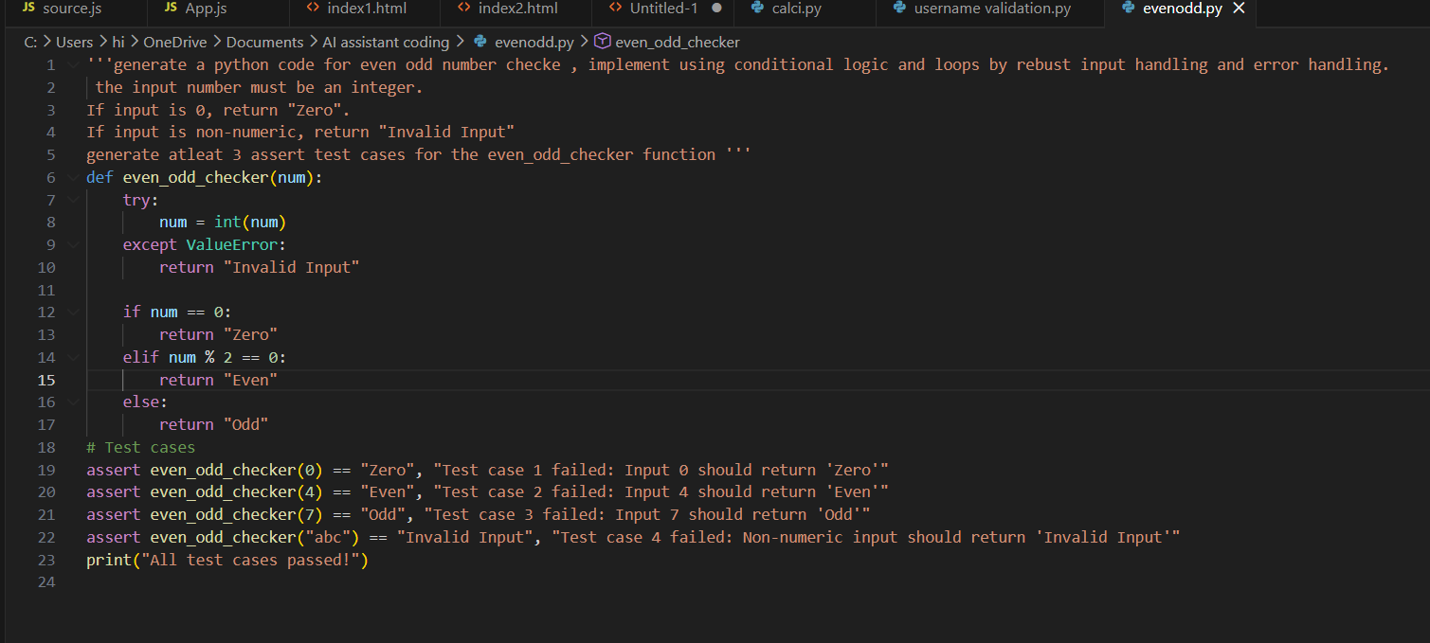

Output:

Explanation:
The even_odd_checker function first attempts to convert the input to an integer. If it fails, it returns "Invalid Input". It then checks if the number is zero, even, or odd and returns the appropriate string.
The test cases cover various scenarios, including zero, even numbers, odd numbers, and non-numeric input. If any assertion fails, an error message will indicate which test case failed.

Task Description #3 (Palindrome Checker – Apply AI for
String Normalization)
• Task: Use AI to generate at least 3 assert test cases for a
function is_palindrome(text) and implement the function.
• Requirements:
o Ignore case, spaces, and punctuation.
o Handle edge cases such as empty strings and single
characters.
Example Assert Test Cases:
assert is_palindrome("Madam") == True
assert is_palindrome("A man a plan a canal Panama") ==
True
assert is_palindrome("Python") == False
Expected Output #3:
• Function correctly identifying palindromes and passing all
AI-generated tests.

Prompt:
'''generate a python code to test the fuction is polindrome using string normalization and implement the function
ignore case, spaces and punctuation
handle the edge cases such as empty string and single character
generate atleat 3 assert test cases for the palindrome function '''

Code:
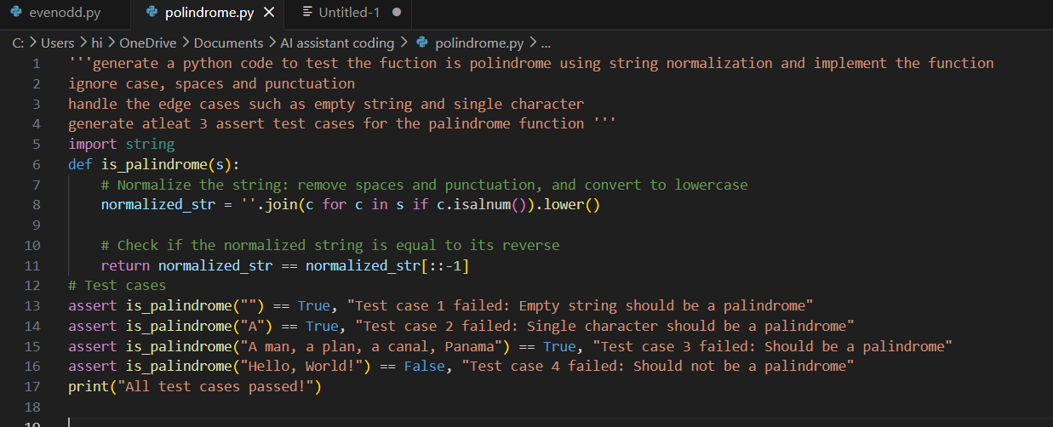

Output:

Explanation:
The is_palindrome function normalizes the input string by removing spaces and punctuation and converting it to lowercase. It then checks if the normalized string is equal to its reverse.
The test cases cover various scenarios, including empty strings, single characters, and strings with spaces and punctuation.

Task Description #4 (BankAccount Class – Apply AI for
Object-Oriented Test-Driven Development)
• Task: Ask AI to generate at least 3 assert-based test cases for
a BankAccount class and then implement the class.
• Methods:
o deposit(amount)
o withdraw(amount)
o get_balance()
Example Assert Test Cases:
acc = BankAccount(1000)
acc.deposit(500)
assert acc.get_balance() == 1500
acc.withdraw(300)
assert acc.get_balance() == 1200
Expected Output #4:
• Fully functional class that passes all AI-generated assertions.

Prompt:
'''generate at least 3 assert-based test cases for a BankAccount class and then implement the class.
• Methods like deposit(amount), withdraw(amount), get_balance()
should handle error cases such as withdrawing more than the balance or depositing negative amounts.
Example Assert Test Cases:
acc = BankAccount(1000)
acc.deposit(500)
assert acc.get_balance() == 1500
acc.withdraw(300)
assert acc.get_balance() == 1200
Expected Output #4:
Fully functional class that passes all AI-generated assertions.'''

Code:
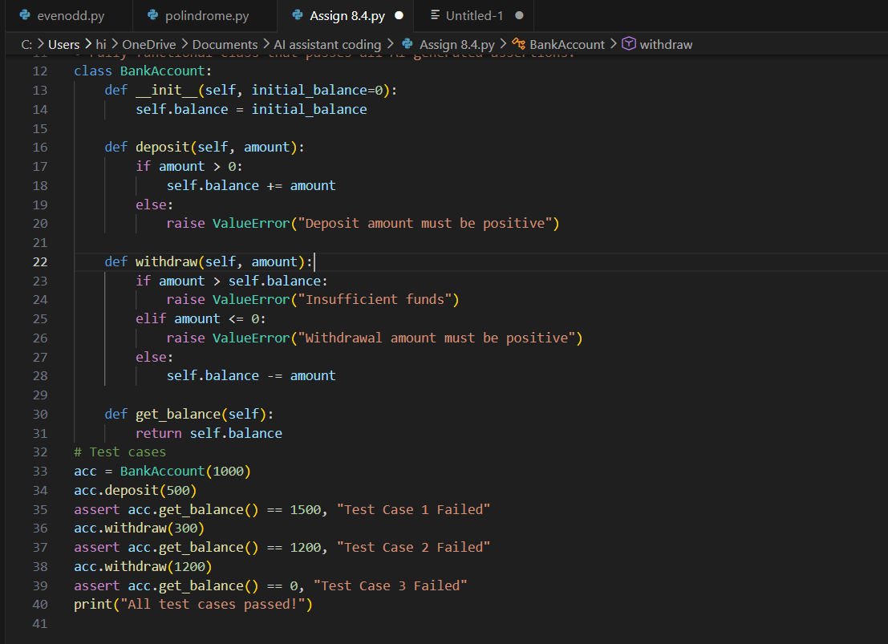

Output:

Explanation:
The BankAccount class has three methods: deposit, withdraw, and get_balance.
The deposit method checks if the amount is positive before adding it to the balance.
The withdraw method checks if the amount is greater than the balance or if it is non-positive before allowing the withdrawal.
The get_balance method simply returns the current balance.
The test cases create an instance of BankAccount, perform a series of deposits and withdrawals, and assert that the balance is correct after each operation. If any assertion fails, an error message will indicate which test case failed.

Task Description #5 (Email ID Validation – Apply AI for Data
Validation)
• Task: Use AI to generate at least 3 assert test cases for a
function validate_email(email) and implement the function.
• Requirements:
o Must contain @ and .
o Must not start or end with special characters.
o Should handle invalid formats gracefully.
Example Assert Test Cases:
assert validate_email("user@example.com") == True
assert validate_email("userexample.com") == False
assert validate_email("@gmail.com") == False
Expected Output #5:
• Email validation function passing all AI-generated test cases
and handling edge cases correctly.

Prompt:
'''generate at least 3 assert test cases for a function validate_email(email) and implement the function.
Requirement: must contain @ and . and must not start or end with special characters.
Should handle invalid formats gracefully.
Example Assert Test Cases:
assert validate_email("user@example.com") == True
assert validate_email("userexample.com") == False
assert validate_email("@gmail.com") == False

and handling edge cases correctly.'''

Code:
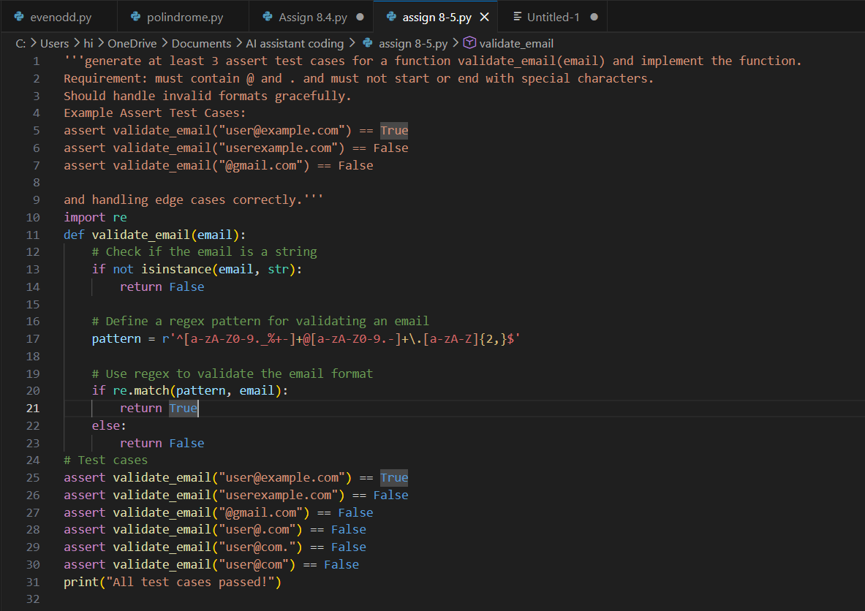

OutPut:

Explanation:
The function validate_email checks if the input email is a valid string and matches a specific regex pattern.
The regex pattern ensures that the email contains characters before and after the '@' symbol, and that it ends with a valid domain format.
The test cases cover valid and invalid email formats, including edge cases where the email starts or ends with special characters.

